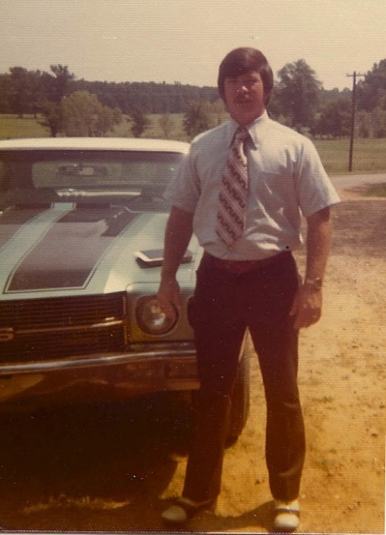
This Man and this 1970 Chevelle SS 454 are Changing Bodies … and Bringing Youthful Energy and Life-Changing Fitness To The Men Of Matthews, NC
DELETE THIS BOX …. Change this to your town
Why this seemingly odd letter could mean the difference between spending the next 20, 30, or 40 years crossing adventures off your “bucket list” … OR … not
(Greg, with his 1970 Chevelle SS 454)

Do you remember the first time You saw one? For Greg, “one” was a 1970 Chevelle SS 454. He tells me he could actually FEEL (literally) how bad he wanted to jump behind the wheel and fire that baby up. RAW dominating power ... that’s what it was … it was loud, and powerful, and absolutely had to be driven … fast. Fathom Blue, with dual black racing stripes … fat BF Goodrich tires, solid chrome super sport rims with the little black SS in the middle … and of course, the hood scoop, which meant only one thing … more power.
It took a few years … but Greg says he can remember walking onto the car lot (in his blue leisure suit) absolutely beaming the first time he could actually afford to buy one … he was a few years out of school, he had worked hard, he had saved his money … and he had earned it. Driving it off the lot was a dream come true.
Time flies when you’re having fun. 35 years and a few speeding tickets later … Greg still loves his muscle cars … in fact ... he built a shop in his backyard where, as a hobby, he works on them to this day. He’s got years of experience under his belt and when he’s done revitalizing one the results are incredible … his cars look and run like they did the day they rolled out of the factory … Actually, Greg’s are even better … because they didn’t come out of the factory with a cherry-bomb glass pack muffler. For Pete’s sake … He even found an original copy of the window sticker for a 330 Boss Mustang he restored and put it in the window … now THAT’S how it’s done the old school way …. the RIGHT way!
I’m in the “restoration” business myself … but I don’t spend hours sanding one spot to get it perfect or work tirelessly to get the carburetor set just right so the engine runs perfectly. Nope ….. I work tirelessly fine-tuning the bodies of many of your neighbors, so they “run” great … so they’re filled with energy day in and day out, so they look and feel EVEN BETTER than they did a few years back …. when they caught the first glimpse of their “1970 Chevrolet Chevelle SS”.
I’ve got 2 very important questions for you …
If you could combine the life experience, knowledge, and wisdom you’ve gained over the last 20-30 years … with renewed energy, strength, stamina, and endurance … what would the next 40 years of your life “look” like?
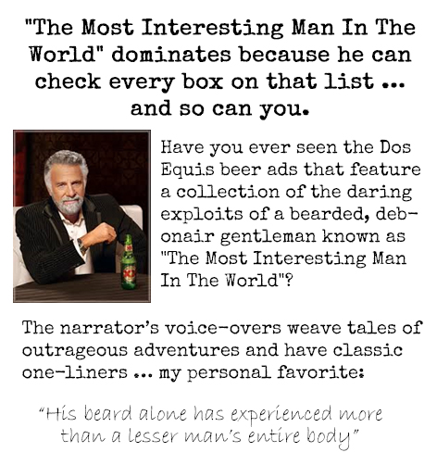
The answer is simple … You would THRIVE … career, marriage, single life, travel, golf, etc … whatever … YOU WOULD THRIVE.
Not only would you thrive … you would DOMINATE
Why? …. Well, because these characteristics:
Life experience
Knowledge
and Wisdom
… COMBINED WITH THESE CHARACTERISTICS …
Functional, Real-World Strength
Undeniable Stamina and Endurance
Boundless and Limitless Energy
Life Free from Needless Aches and Pains
… and a Body That Matches
are a VERY RARE combination.
Very few people can check off all of the boxes on that list ... but when YOU do, you separate yourself from “the competition”. Whether you’re competing for career advancement, competing on the back 9, or competing with yourself to live a more fulfilling, more satisfying life … you have the edge, you thrive and you dominate.
Take a look around you … look at your peers.
Do any possess ALL of these qualities? Statistically speaking, probably not. But on the off chance that one or two do … Do they thrive? … I bet they do. I bet they squeeze every last drop of joy and adventure from every day. I bet they rarely say no to opportunities … whether it’s as simple as an invitation to spend a night out with the guys, or as complex as evaluating a new business venture.
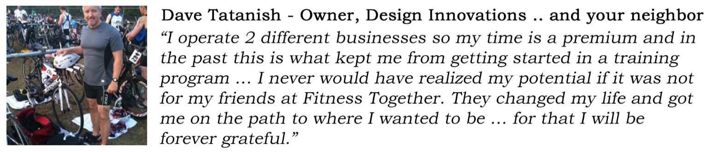
People with all of these characteristics are filled with the confidence and energy that only comes with the combination of intellectual fitness and physical fitness … a sharp mind AND a sharp body.
“To deserve something; to acquire something as a result of personal actions or behavior”… that’s the definition of the word “Earn”.
Do you deserve to live a more satisfying, fulfilling life? As a result of your personal actions and behavior, are you at a point in your life where you are justified in investing in yourself … in your health … in your happiness?
In my opinion, many today have no issue with “acquiring something”, everybody will line up for that, right? It’s the “as a result of personal actions or behavior” that all too often appears to be a fading value. Greg EARNED that Chevelle …
What about you?
I bet that you’re more like Greg … an “earner”. Has your success in life been the result of your personal actions and behavior (i.e. hard work) … did you earn it? Probably … because that’s how the world works. Could you just be the luckiest guy on the planet and have won the lottery, or found out that your long lost uncle invented the ChiaPet and left you everything … or both!? … Sure, but I’ll take my chances that the former is closer to reality.
It’s true … we’re ALL lucky … we’re all fortunate … we’re all blessed to live in this country, even as screwed up as it can be sometimes. My wife tells me how lucky I am every day (she happens to be correct), but have you ever noticed how “lucky” you get, when you put the work in? Funny how that works.
DELETE THIS BOX …. Change these two highlights to reflect your situation (girlfriend … husband … whatever)
You deserve to feel good, you’ve earned it … to feel healthy and strong ... to have the energy to do the things you want to do, to perform well and to do so without giving it a second thought … without wondering … “Will I pay for this later?” … When you’re fit, lean and toned; when your blood pressure and heart rate are low and steady; when stress is decreased or eliminated altogether; when your focus is razor sharp; when you feel really good – not just healthy – but also proud of your appearance (and your spouse starts giving you those looks again)… that’s when life is at its best. That’s when every day is an adventure you can’t wait to start. That’s when you thrive. That’s when you dominate.

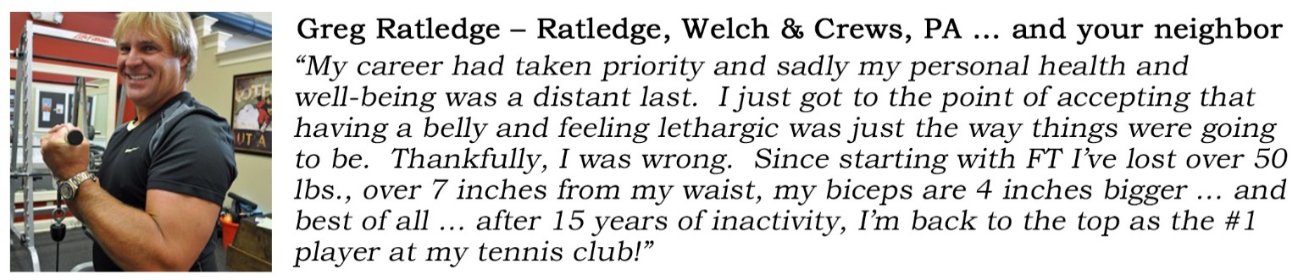
You are 1 in a Million 7.1 Billion …
Your body is different than mine, it’s different from your neighbors, from your friends and your co-workers … Sure, at birth we all started off pretty similar, but not anymore. Life happened.
You are unique. Your unique life experiences combined with your genetics (thanks a lot mom and dad) have brought you to where you are today. There were sports injuries, car accidents, trips, falls, an occasional rough night out, surgeries, broken ankles, high arches, flat feet, torn ACL’s, torn MCL’s, etc. … therefore …. “Bad” backs, “bad” knees, “bad” shoulders, “bad” elbows … and the list goes on and on and on. YOU ARE UNIQUE!
Let me share a quick story …. Imagine this ….
You walk into Belk at Southpark mall and mention to the attractive gal working in the men’s department that you’re looking for a new pair of pants. “Yes sir” she replies, “Right over here”. She grabs a pair off the rack, folds them neatly and says “Your total is $86.57, will that be cash or credit?” …. You’re confused.
DELETE THIS BOX …. Change this to a store/mall that your prospects will be familiar with
“Wait a minute, you don’t know my size? … How do I know these are right for me?”. “Ohh, don’t worry sir” she says, “these are one size fits all”.
What would you do? You’d say no thanks and walk out (I hope) because that’s ridiculous. The chances that these pants are going to be the right fit for you are slim to none. Sure, you could gamble and take the pants … hey, you DO need pants after all and these ARE pants … Worst case they don’t fit, right? So it cost you a couple bucks, but at the end of the day, no harm no foul … right? WRONG.
Obviously, this would never happen because it doesn’t make sense … people are clearly different on the outside … it’s not rocket science.
So, if the one size fits all approach doesn’t make sense with something as insignificant as pants … why in the world would it make sense with training and with YOUR body??? … something VERY SIGNIFICANT. The answer? It doesn’t.
Yet that’s what happens every day in every “gym”. I can’t tell you how many times I’ve been a fly on the wall watching some sort of class, bootcamp, crossfit … whatever. Typically, no less than half the class is doing the exercise wrong. Not only is it ineffective, but … it’s dangerous.
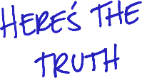
If the average group training instructor was educated and honest, this is what they’d tell you:
“Hey everybody … you’re all completely different, but let’s all train the exact same way … it’ll work a little for 1/3 of you … it won’t work at all for another 1/3 … and the last 1/3? Well … you’re probably going to leave worse off than when you started … sound good? Great! Let’s get started!”
Common sense tells you that you can’t apply a “one size fits all” approach to buying pants … unfortunately most people don’t apply the same thinking when it comes to taking care of their body. In fairness … it happens because it’s not as obvious that we’re all different on the inside. For example, everybody can look at someone else and conclude that they’re tall or short ... it’s right there in plain sight … “that person is tall” … it doesn’t take an expert … it takes someone with eyes.
Not everybody, on the other hand can look at someone and tell just by the way that they move that they’ve got tight hip flexors and weak abdominals (for example) … and as a result likely suffer from low back pain … and because of that, should not be doing exercises A, B, and C … and instead should be doing exercises D, E, and F to eliminate pain and restore proper function first, … that takes an expert … that’s us.
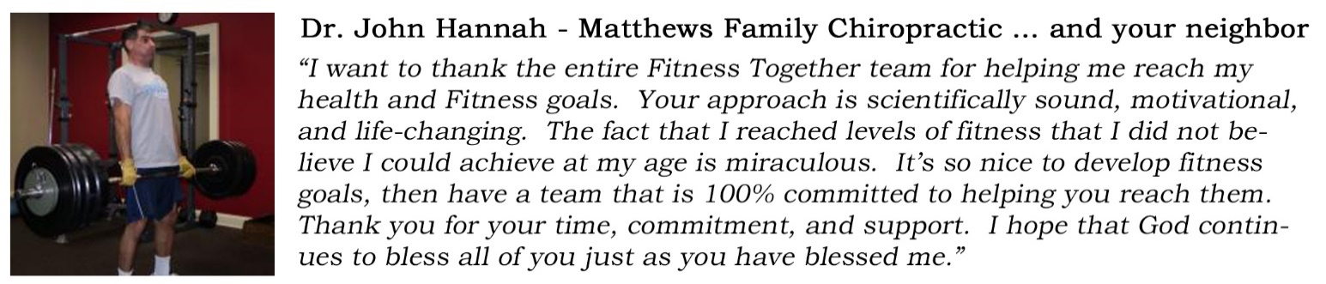
Please understand, I don’t say this to be arrogant or braggadocios. I say it because it’s true … because it’s of great importance, and because trusting your body, and your health and fitness to anything less than an expert is a bad idea … and it’s dangerous.
We don’t do “one-size fits all”.
We specialize in One-on-One Personal Training and Small Group Private Personal Training, limited to 4 participants. That means when you train with us … you train in private … with the best, most educated and experienced trainers in the business … You’ll train in the privacy of a fully-equipped training suite. There are no distractions … there is no sharing of equipment. You have the full attention of your trainer, who coaches you step by step through programming designed specifically to ensure that you achieve your goals … and you’ll have an unparalleled experience along the way.
DELETE THIS BOX …. Delete highlight if you don’t do PACK … you may need to add an extra blank line at the bottom to maintain the formatting of the rest of the letter
My team and I meet with many of your neighbors several times a week and the results speak for themselves … they’re littered throughout this letter … and there’s plenty more where these came from …

Why should You trust Me?
Just like Greg and his muscle cars, I’ve spent years fine-tuning my craft, and building the best team of experts in the business … creating an environment and systems that enable us to deliver a one of a kind experience, and the results that you and the rest of our clients deserve.
Just like Greg, I know how to do it the right way … how an adjustment of even the smallest detail effects your results … how and why what’s going on inside your body effects how you feel … and how you look on the outside.
- The Right Team –
  - My staff and I have accumulated 23 college degrees, 47 additional nationally-recognized training certifications, and more than 35 years of experience.
DELETE THIS BOX …. Replace these 3 accolades with your own … add up your entire staff’s achievements … what awards have you received? … have you run commercials on TV or Radio? (if so, then you’ve been “featured”
  - I co-hosted a live call-in radio show every Saturday morning at WBT, on 107.9 The Link for over 5 years … and still would be had the station not asked us to move to Sunday’s … (for me … Sunday’s are for church and family, so I said no thanks).
  - We’ve been featured as guest experts on WBTV (CBS), WCNC (NBC), WCCB (FOX), and WSOC (ABC) … we even hosted the 2 casting calls for NBC’s The Biggest Loser.
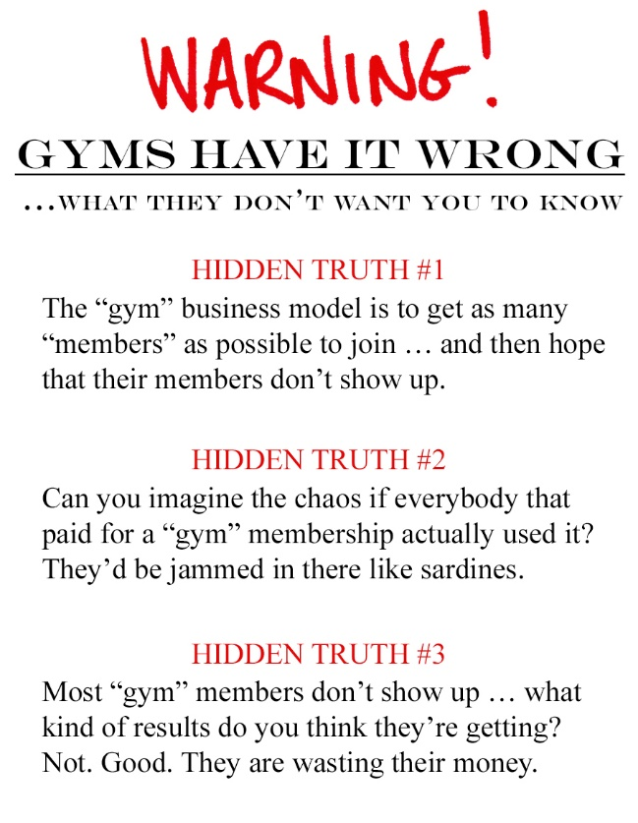
- The Right Client Experience – Our business is very successful because it’s built on relationships and delivering results. In fact … our vision statement is:
“To Enhance Lives And Build Relationships Through The Experience Of Fitness Together”
Each member of our staff has a black wristband that says “Enhance Lives” in blue on one side and “Build Relationships” in green on the other … they wear it, not because it’s required, but because their personal values are in line with our company values. Our staff actually care … crazy concept, huh? The band is an external representation of an internal commitment to our clients, to each other, and to the community to make a difference.

- The Right Environment – We’ve created an environment that is 100% centered on your success.
  - Efficient – Your time is valuable and we value that. Your training sessions are by regularly scheduled appointment and your trainer is prepared for your session when you arrive … there is no “sorry, we’re running a bit behind”
  - Clean – We take pride in being the crème of the crop and treat our studio with the same level of consideration and respect that we show our clients. The studio’s common areas are cleaned twice per day and the training rooms and equipment are cleaned between each training session.
  - Safe – There is no safer way to train than in an environment free of distractions under the guidance, coaching, and supervision of the best trainers in the business.
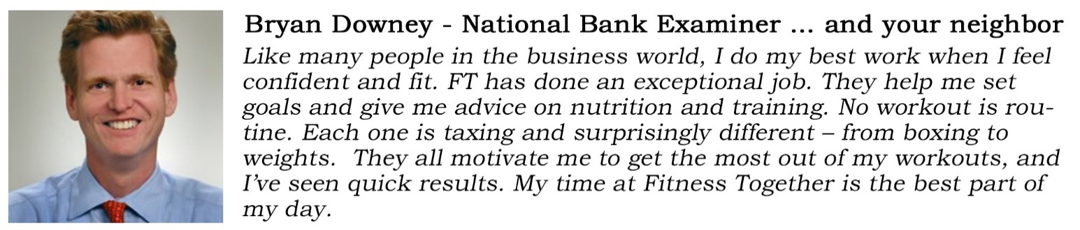
  - Customized - No “cookie cutter” workouts here. Your workouts are designed specifically for you and for your body. Your program is designed to move you along the health continuum … taking you one step at a time from your current fitness level, to your goal … and then beyond.
- The Right Systems –
  - Aspire8 - Our proprietary fitness programming platform. It’s the science behind the success of our strength training, and corrective exercise programming.
DELETE THIS BOX …. Remove (b) PACK if you don’t do PACK … don’t worry about whether or not you do Aspire8, Cardio Together and Nutrition Together (i.e. leave them in here) … the point is that you have a systematic process for results
  - PACK - Private Small Group Personal Training, which may or may not play a role in your programming (capped at 4 participants) was designed in our studio … and is now the format and programming of choice of over 212 personal training studios across the country.
  - Cardio Together – Our proprietary cardiovascular training platform, which provides cardio programming for your non-“Training” days.
  - Nutrition Together – Our proprietary nutritional platform is designed to educate you in the principles of a healthy diet through private one-on-one meetings, regular journal review, and consistent accountability.
- The Right Equipment –
  - Our most valuable and effective piece of equipment is our brains. Unlike typical gyms, we understand that the equipment is just a tool. In the hands of a skilled craftsman, the results are fantastic … in the hands of an amateur, even the best tool is worthless.
  - The training equipment that we use is top of the line, and is cared for as such. We have all the tools (equipment) we need, and the knowledge and experience to maximize its effectiveness.
- Guarantee –
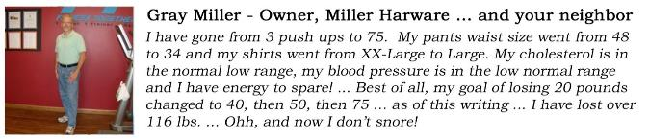
  - Yes. WE GUARANTEE a top-notch experience and results …
You’ve got a decision to make. This is where the rubber meets the road. If you’ve read this far, it’s fair to say that you have an interest in living a healthier, fitter, happier, more productive life …
I’ve put together a strong offer to get you off the starting line, because I believe that in fitness, just like in business … and in every other aspect of life, success is a result of taking DELIBERATE ACTION.
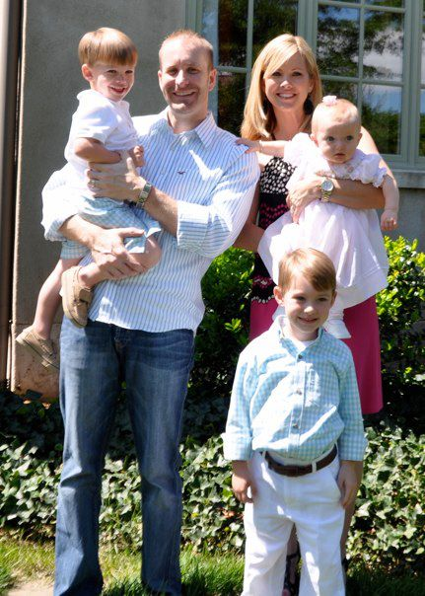
I’m taking MASSIVE DELIBERATE ACTION.
Me, Lindsey, Jack, Luke, and Stella Jane
… and here it is … In honor of Greg and all of those who are relentlessly committed to perfecting their craft, I’d like to gift you with:
DELETE THIS BOX ….

Put your own pic and caption in … and don’t forget to change the signature line
2 private One-on-One Training Sessions and a Health and Fitness Consult (valued at $249)… for FREE.
I’m going to take massive deliberate action on your behalf … now it’s your turn to do the same … but I’m not crazy, so please pay close attention
… the deadline on your gift card is firm.

In Good Health, Rick Anderson, Owner

