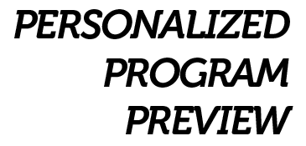

**Program Preview / Recommendations:**

*Flexibility prescription for total body and specific joint stretching. This can be done at home, before or after a session, or you can come here on an off day to carry out.*

*Cardio prescription that is designed specifically around your heart and lungs, intensity is measured by a heart rate monitor/watch that we will provide for you to keep. Cardio Prescriptions can also be designed to do anywhere, as well as here on off days.*

*An exercise prescription, this is what you will do here with a trainer in a 1on1 or small group (called PACK) setting. It will change every time you see your trainers; we update your file and work and communicate as a team to get you to your goals as fast as possible. We can also plan this around what you are doing in MN.*

*You will see our nutrition coach about diet/food/meals as needed.*

*Exercise testing every 6-8 weeks to see your personal improvements in over 50 different tests and printed off for you in a report.*

*A team of exercise physiologists and kinesiologists to help with accountability and anything else that comes up.*

*You are going to look and feel better by losing fat, gaining strength, and getting more tone!*

**Additional Comments:** *Ready to get in better shape for my grandkids … want to get ready for my youngest daughter’s wedding as well*

**Injuries/Surgeries:** *Bum Shoulder, bum hip*

**Exercise History:** *Not too much…a gym membership.*

**Goals:** *To improve my performance and get into better shape.*

**Date:** *01/01/2019*

**Prepared for:** *Jane Doe*

**Prepared by:** *Studio McOwner*